**Guided Solution for Tutorial 2**

**Q2**

1. Apply the formula



2. There are 3 loops so the above will be a 3 X 3 matrix

3. The mutual impedance will be negative if the loop currents are in the opposite direction.

4. To solve for the unknown loop currents use Cramer’s rule or find using the determinant

method

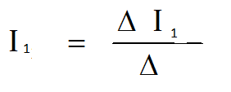



** I1  ,  I2  and  I3  can be found by replacing the first, second and third column in matrix  by the [V] column matrix respectively.**